

**Man Walking In The Rain**

Academic Year: 2023-24 Program Code: CO3I

Course: CGR Course Code: 22318

Submitted By:

|  |  |  |  |  |
| --- | --- | --- | --- | --- |
| Roll No | Student Name | Branch | Batch | Enrollment Number |
| 1526 | Shubham Dinesh Giri | SYCO | C0-2 | 2201410262 |
| 1550 | Rushi Raviraj Gujarathi | SYCO | C0-2 | 2201410263 |
| 1551 | Param Bhimrao Jadhav | SYCO | C0-2 | 2201410267 |

**Under Guidance of:**

Ms.P.V.Shitole

iShri KENNEDY ROAD, NEAR R.T.O., PUNE 411001



Institute Code: 0141

# CERTIFICATE

Certified that this micro project report titled “**Man walking in the rain**” is the bonafide work of Ms. /Mr. Shubham Giri, Rushi Gujarathi, Param Jadhav Roll no. 1525,1526,1527 of second year diploma in Computer Engineering for the course: **Computer Graphics** Course code: **22318** during the academic year 2023-2024, who carried out the micro project work under my supervision.

**Ms. P.V.Shitole**

Name & signature of subject teacher

**INDEX**

|  |  |  |
| --- | --- | --- |
| **Sr. No.** | **Content** | **Page No.** |
| 1. | Annexure I | 4-6 |
| 2. | Micro Project Proposal | 4-6 |
| 3. | Annexure II | 7-12 |
| 4. | Rationale | 7 |
| 5. | Aims/Benefits of the Micro Project | 7 |
| 6. | Course Outcome achieved | 7 |
| 7. | Literature Review | 7 |
| 8. | Actual Methodology Followed | 8 |
| 9. | Actual Resources Used | 9 |
| 10. | Output of the Micro Projects | 9-11 |
| 11. | Skill Developed / Learning outcome of the Micro Project | 12 |
| 12. | Applications of the Micro Project | 12 |
| 13. | Annexure III | 13-14 |
| 14. | Annexure IV | 15-17 |
| 15. | Log Book | 18 |

**ANNEXURE I**

**Micro Project Proposal**

## Man Walking In The Rain

**1.0 Aims/Benefit of the Micro Project:**

We use graphics functions to draw various shapes (circle, rectangle, etc.) and to show text (any message) in various formats (different fonts and colours). We can create a program, animations, and games using graphics.

**2.0 Course Outcomes Addressed:**

1. Manipulate visual and geometric information of images.
2. Implement standard algorithm to draw various graphics objects using c program.
3. Develop programs for 2-D and 3-D Transformations.
4. Use projections to visualize objects to view the clock.
5. Implement various clipping algorithms.
6. Develop programs to create curves using algorithms.

**3.0 Proposed Methodology:**

1. Start with a simple objects: Select one topic for micro project that you find very simple.
2. Consult with your teacher for finalization of circuits/Charts.
3. Make draft copy of micro project proposal.
4. Take approval from teacher.
5. Make list of resources required such as raw material, instruments, software.
6. Execute Micro project.
7. Test Micro project.
8. Observe outputs/Results of Micro project.
9. Prepare Micro Project Presentation.
10. Prepare Micro project report for submission.

**4.0 Action Plan:**

|  |  |  |  |  |
| --- | --- | --- | --- | --- |
| **Sr. No.** | **Details of Activity** | **Planned Start Date** | **Planned**  **Finish**  **Date** | **Name of Responsible Team Members** |
| 1 | Formation of groups | 01.10.2023 | 01.10.2023 | All members |
| 2 | Selected the topic for micro project | 01.10.2023 | 01.10.2023 | All members |
| 3 | Discussed about the project | 01.10.2023 | 01.10.2023 | All members |
| 4 | Assigned the work to each group member | 01.10.2023 | 01.10.2023 | All members |
| 5 | Detailed study of micro-project | 02.10.2023 | 02.10.2023 | All members |
| 6 | Collected information on assignment topic | 02.10.2023 | 02.10.2023 | Shubham Dinesh Giri ,  Rushi Raviraj Gujarathi ,  Param Bhimrao Jadhav. |
| 7 | Started working on microproject | 03.10.2023 | 03.10.2023 | Shubham Dinesh Giri ,  Rushi Raviraj Gujarathi ,  Param Bhimrao Jadhav. |
| 8 | Assembled all the data | 04.10.2023 | 04.10.2023 | Shubham Dinesh Giri ,  Rushi Raviraj Gujarathi ,  Param Bhimrao Jadhav. |
| 9 | Evaluation of data | 05.10.2023 | 05.10.2023 | All members |
| 10 | Prepared rough copy of microproject | 06.10.2023 | 06.10.2023 | All members |
| 11 | Project proposal presentation to guide | 07.10.2023 | 07.10.2023 | All members |
| 12 | Corrected the micro-project suggested by guide | 07.10.2023 | 07.10.2023 | All members |
| 13 | Actual implementation of micro-project | 07.10.2023 | 07.10.2023 | Shubham Dinesh Giri ,  Rushi Raviraj Gujarathi ,  Param Bhimrao Jadhav. |
| 14 | Execution of overall data / prepared final draft copy | 08.10.2023 | 08.10.2023 | Shubham Dinesh Giri ,  Rushi Raviraj Gujarathi ,  Param Bhimrao Jadhav. |
| 15 | Final micro-project presentation | 09.10.2023 | 09.10.2023 | Shubham Dinesh Giri ,  Rushi Raviraj Gujarathi ,  Param Bhimrao Jadhav. |
| 16 | Micro-project submitted | 10.10.2023 | 10.10.2023 | All members |

**5.0 Resources Required :**

|  |  |  |  |  |
| --- | --- | --- | --- | --- |
| **Sr.**  **No.** | **Name of**  **Resource/material** | **Specifications** | **Quantity** | **Remarks** |
| 1 | Computer system | Any desktop or laptop computer with basic configuration | one system |  |
| 2 | Turbo C | Turbo c 3.1.ink, 645 bytes | - |  |
| 3 | Office software package | MS office or any other such software | - |  |

**Name of Team Members with Roll No:**

|  |  |  |
| --- | --- | --- |
| **Sr. No** | **Name of Students** | **Roll No** |
| **1** | **Shubham Dinesh Giri** , | **1525** |
| **2** | **Rushi Raviraj Gujarathi** | **1526** |
| **3** | **Param Bhimrao Jadhav**. | **1527** |

### Ms.P.V.Shitole

**(Name & Signature of faculty)**

|  |  |
| --- | --- |
|  | **ANNEXURE - II**  **Micro Project Report**  **Man walking in the rain**    **1.0 Rationale:**  This project gives an introduction to computer graphics principles. The project's focus will be on understanding how the many parts that underpin computer graphics interact in the creation of graphics software systems, as well as how to quickly and easily create amazing visuals.    **2.0 Aims/Benefits of the Micro Project:**  We use graphics functions to draw various shapes (circle, rectangle, etc.) and to show text (any message) in various formats (different fonts and colours). We can create a program, animations, and games using graphics.    **3.0 Course Outcomes Achieved:**   1. Manipulate visual and geometric information of images. 2. Implement standard algorithm to draw various graphics objects using c program.     **4.0 Literature Review:**   * + In this project which we were given a task on creating a project which will be useful to understand the concepts of computer graphics. Thus, by using C we were creating a program for Man walking in the rain.   + We were hoping that this program can be beneficial to all of us to understand the 2D concepts in better way.   + Hence, in order to make this program we must need to understand what functions should we need to create project using C.   + In the above mentioned project, we need to draw a man, rain and some other background details has been added.   + In order to do so, a man has been created using line and circle function. Rain has been shown by using the special symbol ‘/’. Other few background details like road and clouds has been designed using line function and arc functions respectively.   + As our project is titled ‘Man walking in the rain’ more emphasis has been given on raining and the man walking.   + For the same purpose we have used for loop. Therefore, by using all above functions and mentioned procedures we have successfully designed our project entitled “Man walking in the rain”. This also included our co-ordination, team work, imagination and creativity.   + The past few years have seen a rapid evolution of the field with novel consumer-level devices (e.g. head-mounted displays) and media (e.g. 3D videos on YouTube) enabling a much wider section of the population to experience and create 3D content.   + However, teaching computer graphics can be challenging due to it requiring a diverse range of skills such as mathematics, physics, programming, spatial reasoning, problem solving, and art and design.   + Several researchers have acknowledged this problem and have attempted to make computer graphics teaching easier and more effective.   + However, so far no consensus seems to exist about the key problems teachers need to overcome and what concepts and methodologies might help with this   + In this paper, we address this issue by conducting a systematic literature review identifying reported challenges, methodologies, and approaches for teaching computer graphics.   + Our research offers practitioners new insight into computer graphics teaching, which we hope will be useful for curriculum design, developing more effective tools and support for struggling students, and suggesting avenues for future research.     **5.0 Actual Methodology Followed:**     1. Started with a simple proc objects. Selected one topic for micro project that you find very easy and creative. 2. Consulted with our teacher for finalization of title of project. 3. Made draft copy of micro project proposal. 4. Took approval from teacher. 5. Made list of resources required such as raw material, instruments, software. 6. Executed Micro project. 7. Tested Micro project. 8. Observed output/results of Micro project. 9. Prepared Micro Project Presentation. 10. Prepared Micro project report for submission |

**6.0 Actual Resource Used:**

|  |  |  |  |  |
| --- | --- | --- | --- | --- |
| **Sr.**  **No.** | **Name of**  **Resource/material** | **Specifications** | **Quantity** | **Remarks** |
| 1 | Computer system | Any desktop or laptop computer with basic configuration | one system |  |
| 2 | Turbo C++ | Turbo c++ 3.1.ink, 645 bytes | - |  |
| 3 | Office software package | MS office or any other such software | - |  |

**7.0 Outputs of the Micro project:**

**Man walking in the rain**

**Program code:**

#include<stdio.h>

#include<conio.h>

#include<graphics.h>

#include<dos.h> #include<stdlib.h> void cloud()

{ int a=50,b=50,r=50; arc(a,b,45,135,r); arc(a+50,b,45,135,r); arc(a+100,b,45,135,r); arc(a,b,135,225,r); arc(a+50,b,135+90,225+90,r); arc(a,b,135+90,225+90,r); arc(a+100,b,135+90,225+90,r); arc(a+100,b,315,45,r);

a=270;

arc(a,b,45,135,r); arc(a+50,b,45,135,r); arc(a+100,b,45,135,r); arc(a,b,135,225,r); arc(a+50,b,135+90,225+90,r); arc(a,b,135+90,225+90,r); arc(a+100,b,135+90,225+90,r);

arc(a+100,b,315,45,r);

a=480;

arc(a,b,45,135,r); arc(a+50,b,45,135,r); arc(a+100,b,45,135,r); arc(a,b,135,225,r); arc(a+50,b,135+90,225+90,r); arc(a,b,135+90,225+90,r); arc(a+100,b,135+90,225+90,r); arc(a+100,b,315,45,r);

}

void main()

{

int gd=DETECT,gm,i,j,x,y;

initgraph(&gd,&gm,"c:\\turboc3\\bgi");

for(i=0; i<700;i++)

{

/******************************* MAN *********************************/ circle(20+i,200,10);

line(20+i,210,20+i,250);

line(20+i,220,10+i,250); line(20+i,220,30+i,250);

line(20+i,250,30+i,300); line(20+i,250,10+i,300); cloud();

/***************************** ROAD **********************************/ line(0,300,700,300);

/***************************** RAIN ***********************************/ x = getmaxx(); y = getmaxy();

for(j=0;j<100;j++)

{

outtextxy(random(x),random(y),"/");

}

delay(1);

cleardevice();

}

getch(); closegraph();

}

**Output of program:**

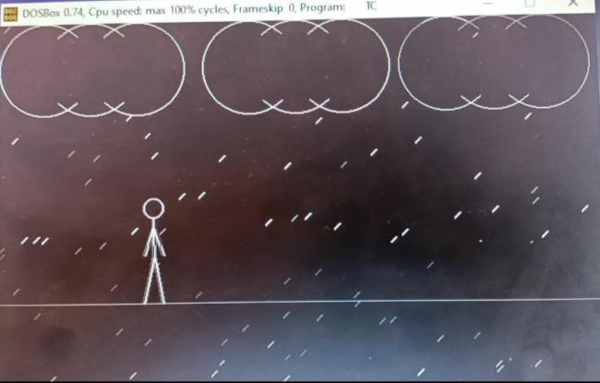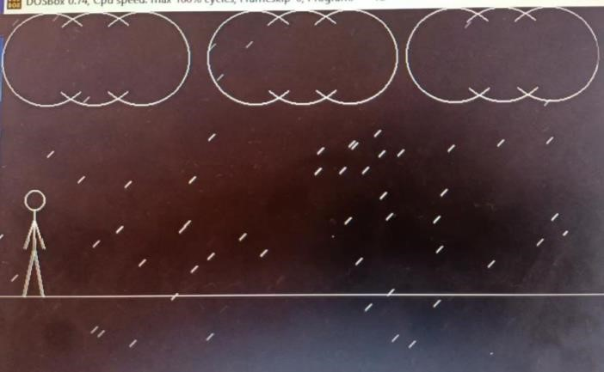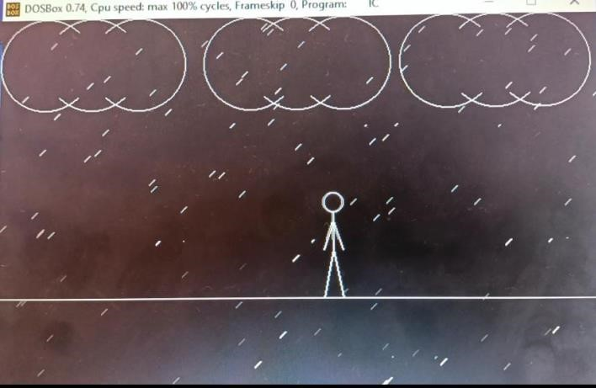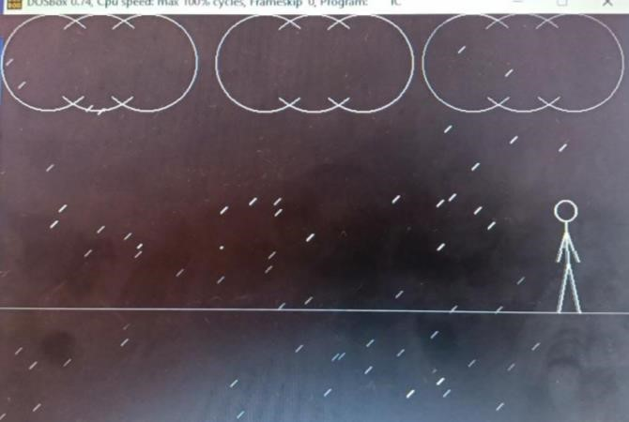

**8.0 Skill developed / Learning outcome of the Micro-Project:**

1. Searching and collecting the information.
2. Arranging the information in proper sequence.
3. Working in a team and as an individual.
4. Presenting information effectively.

**9.0 Applications of the Micro-Project:**

1. We can create fine and commercial art which include animation packages and paint packages.
2. Designing if buildings, automobile, aircraft is done with the help of computer aided drawing.
3. This finds a major part of its utility in the movie industry and game industry.

**Ms.P.V.Shitole**

**(Name & Signature of faculty)**

|  |  |  |  |  |  |
| --- | --- | --- | --- | --- | --- |
|  |  | **ANNEXURE III**    **Rubric for Assessment of a Micro Project** | | | |
| **Sr. No** | **Characteristic to be assessed** | **Indicators for different Levels of Performance (Evaluation Scale: 1-10)** | | | |
| **Poor (1-3)** | **Average (4-5)** | **Good (6-8)** | **Excellent (9-10)** |
| **1** | **Relevance to the course** | Related to vary few LOs | Related to some Los | Addressed at-least one CO | Addressed more than one CO |
| **2** | **Literature review/ information collected** | Not more than two sources( Primary and secondary), very old references | At least five relevant sources, at least 2 latest | At least 7 relevant  sources, most  latest | About 10 relevant sources, most latest |
| **3** | **Completion of target as per project proposal** | Completed less than 50% | Completed 50 to 60% | Completed 60 to 80 % | Completed more than 80 % |
| **4** | **Analysis of data and representatio**  **n** | Sample size small, data neither organized nor  presented well | Sufficient and appropriate sample, enough data generated but not organized and not presented well. No or poor interference drawn. | Sufficient and appropriate sample, enough data generated which is organized and presented well but poor interference drawn. | Enough data collected by sufficient and appropriate sample size. Proper interference drawn by organizing and presenting data through tables, charts and graphs. |
| **5** | **Quality of**  **prototype/Mo**  **del** | Incomplete fabrication/ assembly | Just assembled/ fabricated and parts are not functioning well. Not in proper shape, dimensions beyond tolerance limit.  Appearance/ finish shabby. | Well assembled / fabricated with proper functioning parts. In proper shape, with in tolerance dimensions and good finish. But no creativity in design and use of material. | Well assembled/ fabricated with proper functioning parts. In proper shape, with intolerance dimensions and good appearance/ finish. Creativity in design and use of material. |
| **6** | **Report**  **Preparation** | Very short, poor quality sketches, details about methods, material, precaution and conclusions omitted, some details wrong | Nearly sufficient and correct details about methods, material, precautions and conclusion, but clarity is not there in presentation. But not enough graphic description. | Detailed, correct and clear description of methods, materials, precautions and conclusions. Sufficient graphical description. | Very Detailed, correct and clear description of methods, materials, precautions and conclusions. Enough tables, charts and sketches. |
| **7** | **Presentation of the micro project** | Major  information is not included, information is not well organized. | Includes major information but not well organized and not presented well. | Includes major information well organized but not presented well. | Well organized , includes major information, well presented |
| **8** | **Viva** | Could not reply to considerable number of question | Replied to considerable number of questions but not properly | Replied properly to considerable number of question | Replied most of the questions properly. |

**Ms.P.V.Shitole**

**(Name & signature of faculty)**

### Micro Project Evaluation Sheet

### Name of the student: Shubham Dinesh Giri Enrollement no: 2201410262

**Name of Program:** Computer Engineering  **Semester:** 3I

**Course Name:** Computer Graphics **Code: 22318**

**Title of the Micro-project: “**Man walking in the rain”

**Course Outcomes Achieved:**

1. Manipulate visual and geometric information of images.
2. Implement standard algorithm to draw various graphics objects using c program.

|  |  |  |  |  |  |  |  |  |
| --- | --- | --- | --- | --- | --- | --- | --- | --- |
| **Sr No.** | **Characteristic to be accessed** | **Poor**  **(Marks 1-**  **3)** | **Average**  **(Marks 4-**  **5)** | **Good**  **(Marks 6-**  **8)** | | **Excellent**  **(Marks 9-**  **10)** | | **Sub Total** |
| (A) Process and Product Assessment (Convert above total marks out of 6 Marks) | | | | | | | | |
| 1 | Relevance to the course |  |  | |  |  |  | |
| 2 | Literature  Review/information collection |  |  | |  |  |
| 3 | Completion of the Target as per project proposal |  |  | |  |  |
| 4 | Analysis of Data and representation |  |  | |  |  |
| 5 | Quality of the  Prototype/Model |  |  | |  |  |
| 6 | Report Preparation |  |  | |  |  |
| (B) Individual Presentation/ Viva (Convert above total marks out of 4 Marks) | | | | | | |
| 7 | Presentation |  |  | |  |  |
| 8 | Viva |  |  | |  |  |

|  |  |  |
| --- | --- | --- |
| **(A)**  **Process and Product Assessment (6 Marks)** | **(B)**  **Individual Presentation/**  **Viva**  **(4 Marks)** | **Total Marks 10** |
|  |  |  |

**Comments/ suggestions about Team work/ Leadership/Inter-Personal communication (If**

**any)…………………………………………………………………………………………**

**Name and Designation of the Teacher……………………………………..**

### Micro Project Evaluation Sheet

### Name of the student: Rushi Raviraj Gujarathi Enrollment No: 2201410263

**Name of Program:** Computer Engineering  **Semester:** 3I

**Course Name:** Computer Graphics **Code: 22318**

**Title of the Micro-project: “**Man walking in the rain”

**Course Outcomes Achieved:**

1. Manipulate visual and geometric information of images.
2. Implement standard algorithm to draw various graphics objects using c program.

|  |  |  |  |  |  |  |  |  |
| --- | --- | --- | --- | --- | --- | --- | --- | --- |
| **Sr No.** | **Characteristic to be accessed** | **Poor**  **(Marks 1-**  **3)** | **Average**  **(Marks 4-**  **5)** | **Good**  **(Marks 6-**  **8)** | | **Excellent**  **(Marks 9-**  **10)** | | **Sub Total** |
| (A) Process and Product Assessment (Convert above total marks out of 6 Marks) | | | | | | | | |
| 1 | Relevance to the course |  |  | |  |  |  | |
| 2 | Literature  Review/information collection |  |  | |  |  |
| 3 | Completion of the Target as per project proposal |  |  | |  |  |
| 4 | Analysis of Data and representation |  |  | |  |  |
| 5 | Quality of the  Prototype/Model |  |  | |  |  |
| 6 | Report Preparation |  |  | |  |  |
| (B) Individual Presentation/ Viva (Convert above total marks out of 4 Marks) | | | | | | |
| 7 | Presentation |  |  | |  |  |
| 8 | Viva |  |  | |  |  |

|  |  |  |
| --- | --- | --- |
| **(A)**  **Process and Product Assessment (6 Marks)** | **(B)**  **Individual Presentation/**  **Viva**  **(4 Marks)** | **Total Marks 10** |
|  |  |  |

**Comments/ suggestions about Team work/ Leadership/Inter-Personal communication (If**

**any)…………………………………………………………………………………………**

**Name and Designation of the Teacher……………………………………**

### Micro Project Evaluation Sheet

**Name of the student :**Param Bhimrao Jadhav  **Enrollment No:** 2201410267

**Name of Program:** Computer Engineering  **Semester:** 3I

**Course Name:** Computer Graphics **Code: 22318**

**Title of the Micro-project: “**Man walking in the rain”

**Course Outcomes Achieved:**

1. Manipulate visual and geometric information of images.
2. Implement standard algorithm to draw various graphics objects using c program.

|  |  |  |  |  |  |  |  |  |
| --- | --- | --- | --- | --- | --- | --- | --- | --- |
| **Sr No.** | **Characteristic to be accessed** | **Poor**  **(Marks 1-**  **3)** | **Average**  **(Marks 4-**  **5)** | **Good**  **(Marks 6-**  **8)** | | **Excellent**  **(Marks 9-**  **10)** | | **Sub Total** |
| (A) Process and Product Assessment (Convert above total marks out of 6 Marks) | | | | | | | | |
| 1 | Relevance to the course |  |  | |  |  |  | |
| 2 | Literature  Review/information collection |  |  | |  |  |
| 3 | Completion of the Target as per project proposal |  |  | |  |  |
| 4 | Analysis of Data and representation |  |  | |  |  |
| 5 | Quality of the  Prototype/Model |  |  | |  |  |
| 6 | Report Preparation |  |  | |  |  |
| (B) Individual Presentation/ Viva (Convert above total marks out of 4 Marks) | | | | | | |
| 7 | Presentation |  |  | |  |  |
| 8 | Viva |  |  | |  |  |

|  |  |  |
| --- | --- | --- |
| **(A)**  **Process and Product Assessment (6 Marks)** | **(B)**  **Individual Presentation/**  **Viva**  **(4 Marks)** | **Total Marks 10** |
|  |  |  |

**Comments/ suggestions about Team work/ Leadership/Inter-Personal communication (If**

**any)…………………………………………………………………………………………**

**Name and Designation of the Teacher…………………………………….**

#### Log Book of the Student (Weekly Work Report) Academic Year: 2023-2022

**Name of Students:** Shubham Giri, Rushi Gujarathi, Param Jadhav

**Title of the Project: “**Man walking in the rain”

**Course:** Computer Graphics **Course Code:** 22318 **Semester:** 3I

|  |  |  |  |
| --- | --- | --- | --- |
| **Sr. No./**  **Hour No.** | **Date** | **Time** | **Work Done** |
| **1.** | 01.10.2023 | 4.00pm-5.00pm | Formation of groups |
| **2.** | 01.10.2023 | 4.15pm-5.15pm | Selected the topic for micro project |
| **3.** | 01.10.2023 | 4.00pm-5.00pm | Discussed about the project |
| **4.** | 01.10.2023 | 4.30pm-5.30pm | Assigned the work to each group member |
| **5.** | 02.10.2023 | 4.00pm-5.00pm | Detailed study of micro-project |
| **6.** | 03.10.2023 | 4.00pm-5.00pm | Collected information on assignment topic |
| **7.** | 04.10.2023 | 4.15pm-5.15pm | Started working on micro-project |
| **8.** | 05.10.2023 | 4.00pm-5.00pm | Assembled all the data |
| **9.** | 05.10.2023 | 4.30pm-5.30pm | Evaluation of data |
| **10.** | 16.10.2023 | 3.45pm-4:45pm | Prepared rough copy of micro-project |
| **11.** | 07.10.2023 | 4.00pm-5.00pm | Project proposal presentation to guide |
| **12.** | 08.10.2023 | 4.15pm-5.15pm | Corrected the micro-project suggested by guide |
| **13.** | 09.10.2023 | 4.00pm-5.00pm | Actual implementation of micro-project |
| **14.** | 09.10.2023 | 4.30pm-5.30pm | Execution of overall data / prepared final draft copy |
| **15.** | 10.10.2023 | 4.00pm-5.00pm | Final micro-project presentation |
| **16.** | 10.10.2023 | 4.00pm-5.00pm | Micro-project submitted |

**Ms.P.V.Shitole**

**(Name & Signature of faculty**